Train Station & House Price Analysis

This analysis is carried out using a data set covering over 30,000 sales records from 2016 to 2018 across 345 suburbs in Melbourne provided by Kaggle. The aim of the analysis is to showcase how the transport conveniency (the number of train stations) could affect the average house price in a suburb.

The data set only included data up to 2018 because market behavior changed significantly when COVID-19 pandemic hits the market in 2019. Therefore, to avoid any inaccuracies in the analysis, data from 2019 and onwards were excluded.

In the analysis, two Google API calls were performed to collect the data needed as Google provides highly reliable data source.

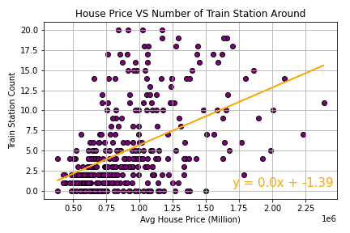

As shown on the graph above, each dot represents a suburb. It tells us that the average house price tends to increase when there are more train stations within 3KM radius from the centre of the suburb.

The analysis could go more in depth than the current analysis, e.g. Within 3KM radius from a train station, how many suburbs are around each station and the relationship of the average house price.

However, such detailed analysis would require longer time to prepare and present.